Assignment 4 Report

Names: Xinya Bi; Xu Wang
Student numbers: 6195350; 6235379

The number of words your report uses: 360

Q1: A paragraph (max. 200 words) explaining how the Python and C++ programs are different (How is the information in the simulation represented: Which data types do the programs use to represent the data for the simulation?)

A1: The CPP version uses static typing and classes vector 3D for 3D coordinates and body classes to store celestial body properties (position, velocity, mass) and fixed size arrays. The python version is dynamic typing, using dictionaries, tuples to store the same information. Positions and velocities are stored in list format.
Features of CPP are strict typing and class structure, this may improve the performance, and python is more flexible in data handling.

Q2: A paragraph reflection on how you went about solving the task (max. 400 words). Which steps did you take? How did you measure the runtime? How did what you learn about Python help you for developing the C++ solution? Did you get stuck? Which sources did you consult when you got stuck? Did you expect the results you obtained? Etc.

A2: I first read the pdf to learn the requirements of the assignment, then I wrote a function in python to output the csv file, making sure it aligns with the required format. Then I test it with different parameters. Then I switched to CPP, read the provided book, and searched online to translate the python csv function into CPP. For runtime, I used the time.perf_counter() at the start and end of the process, and the gap between them is the runtime needed. I first stuck at finding the difference between the released and debugged version of CPP, then I struggled to translate the python function to CPP function. And I didn’t know how to only output the runtime. I searched online for how to process csv file in CPP, (i.e. https://www.geeksforgeeks.org/csv-file-management-using-c/) subprocess (i.e. https://docs.python.org/3/library/subprocess.html) And the results are the same as my expectations, the runtime of python is longer than CPP when iteration increases. However, I don’t know why the debug nbody.exe and the release nbody.exe have slightly different runtime each time I run my runtime test program. I think it may depend on the CPU scheduling or memory availability.

Q3: Timings for Python, C++ Debug and C++ Release, in a table and visualised in a chart (x-axis: instance size/y-axis: run time). Advice: Use matplotlib to produce the chart.

A3: Import the tabulate library to generate a more structured table for output
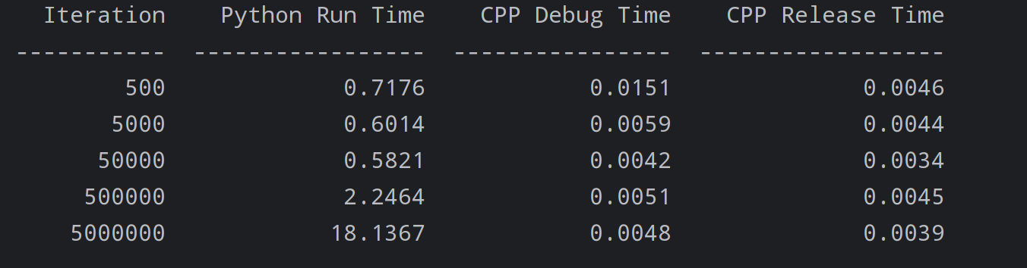
Because in linear scale comparison, it is difficult to distinguish the difference between CPP debug mode and release mode, so we use a log scale on y axis for clarity.
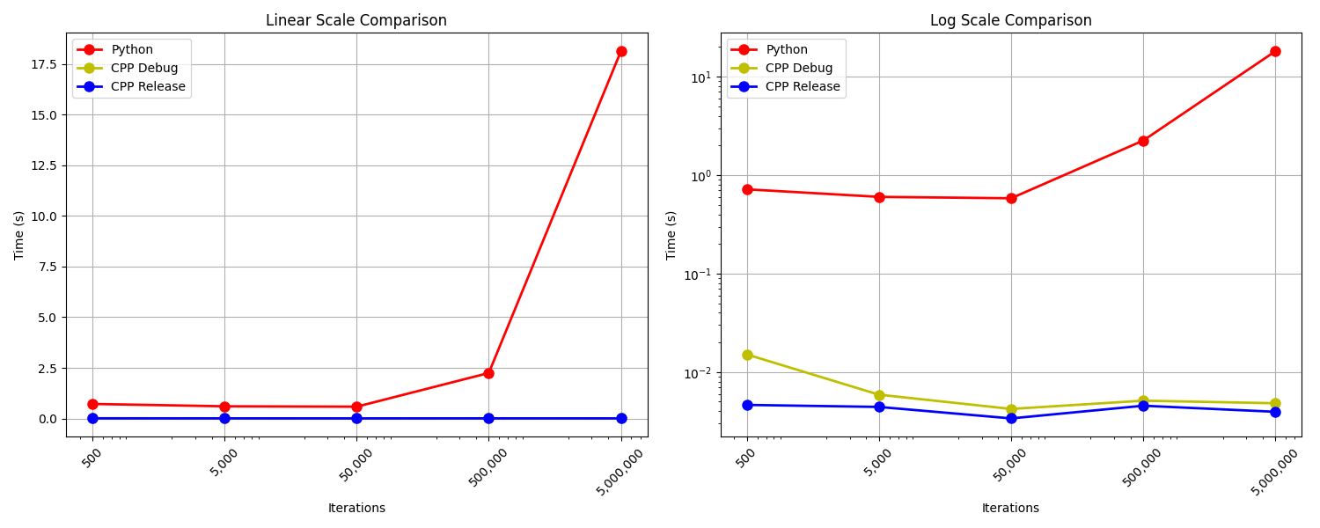

Q4: A short description of the hardware you run the simulation on (CPU, memory, operating system).

A4: CPU: Intel(R) Core(TM) i9-14900HX
RAM: 32GB
Storage: 1TB
Graphics Card: NVIDIA GTX 4060
Operating System: Windows 11

Q5: A screenshot of a failed compilation of one of the sample programs discussed in class
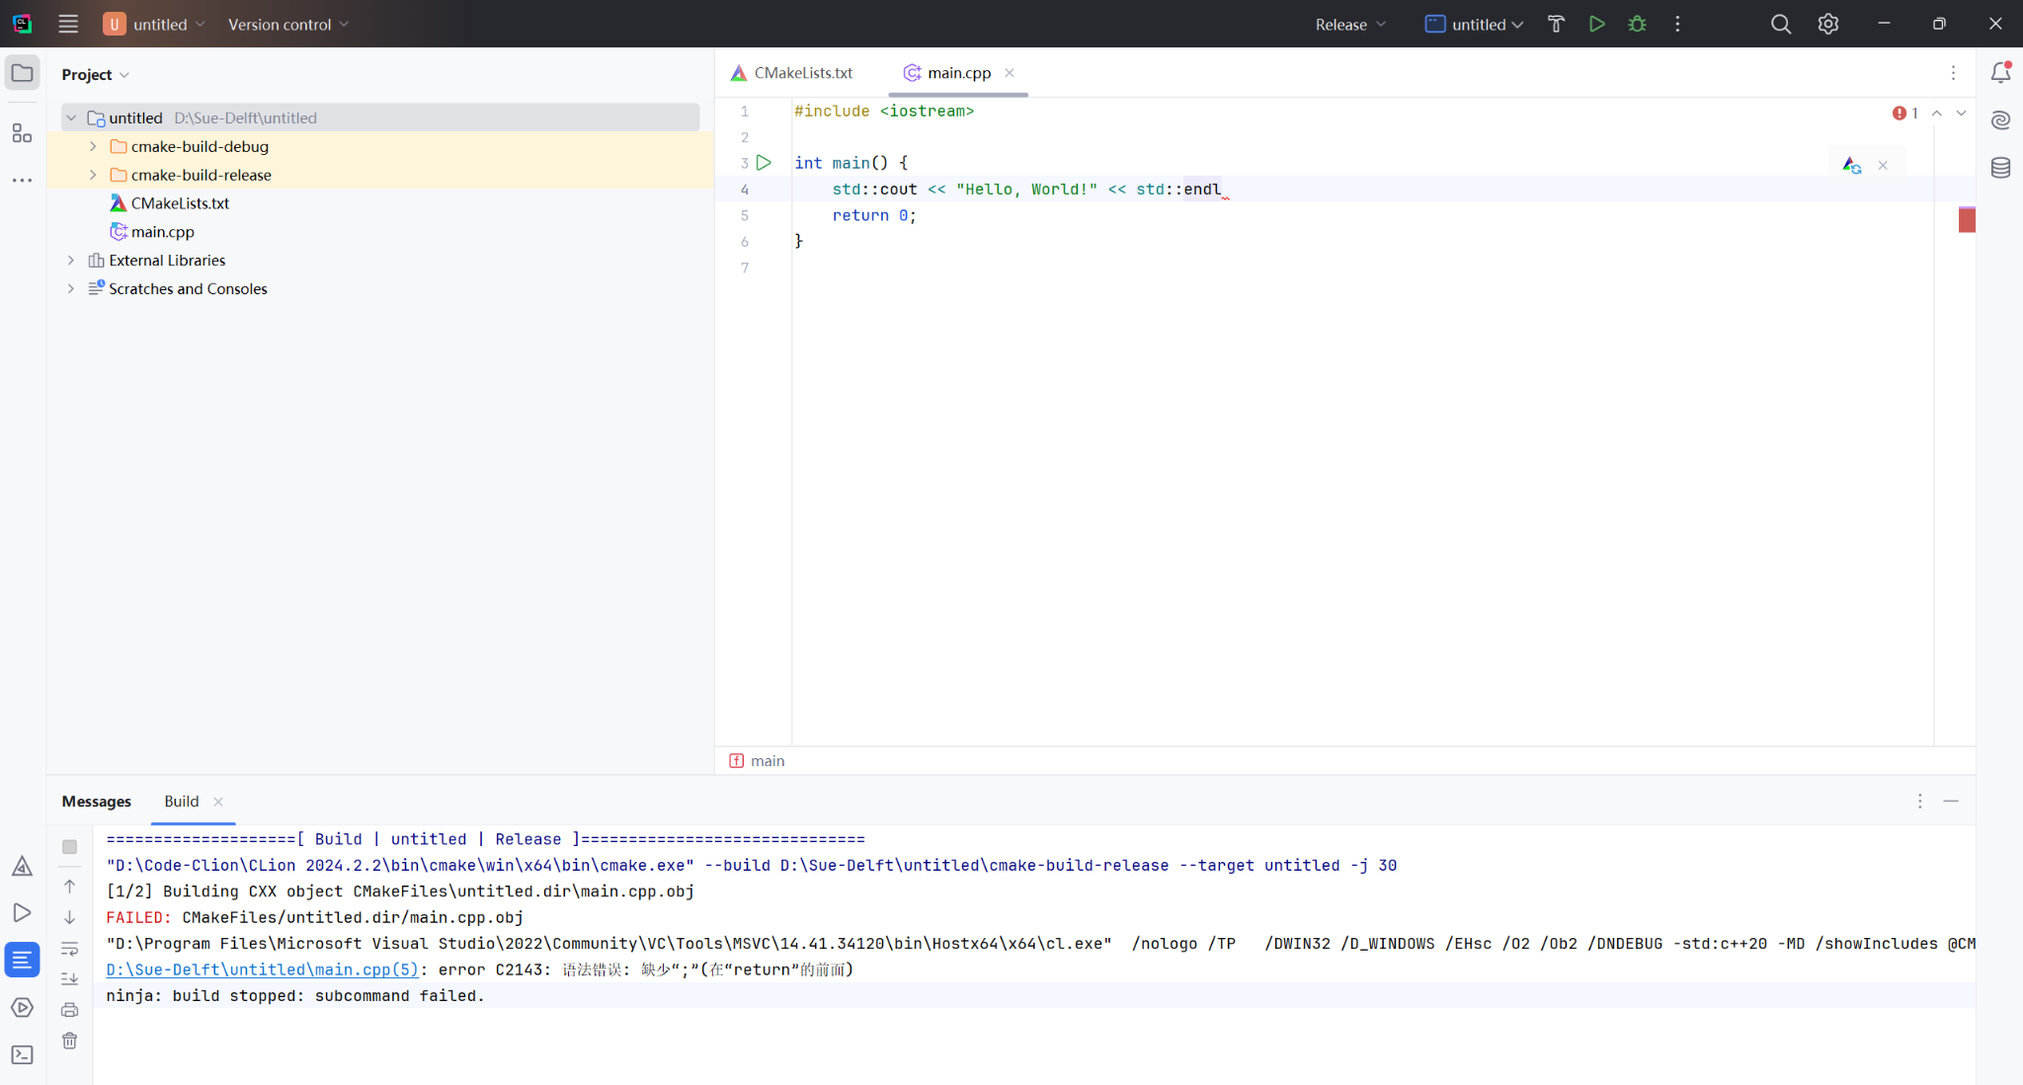
Error I have made: lack a semicolon before endl
To correct the error: add a semicolon before endl
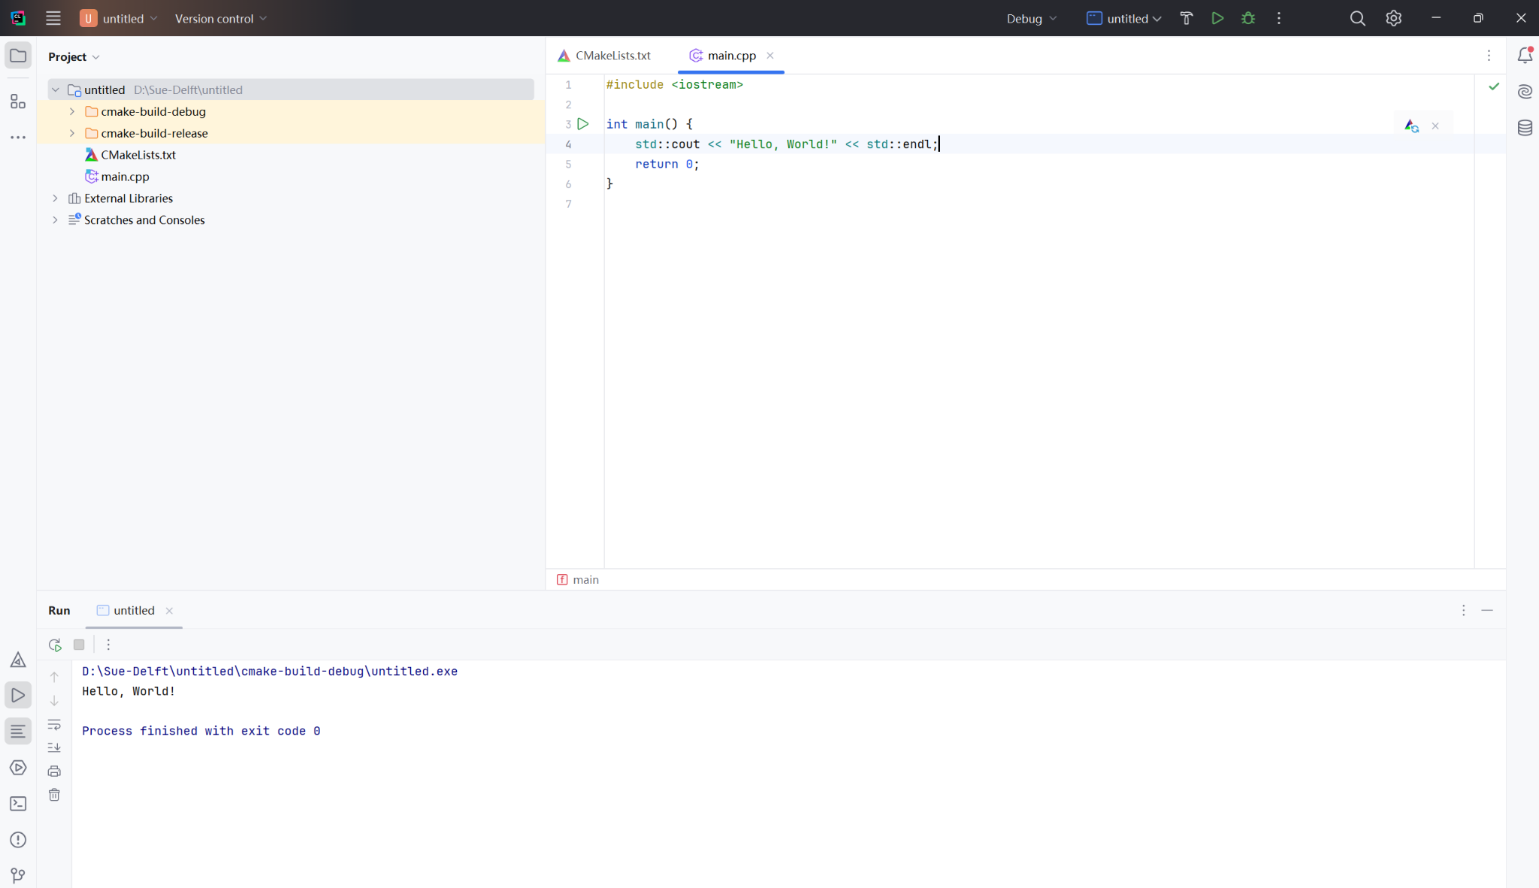

Q6: One (or more, e.g. 1 overview and 1 close-up) screenshot of QGIS, where you have loaded a CSV file your code did produce for 5’000 iterations. If you have a recent version of QGIS, you can try to use the 3D map view as well.
